4. App Logo and Formula Field - 25 Feb 2022

1] App Logo

Go to + 🡪 Documents 🡪 New 🡪 Image Upload.

Quick Find Box 🡪 Apps 🡪 Edit 🡪 Image Assign.

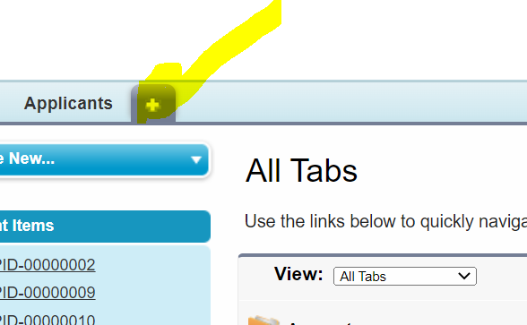

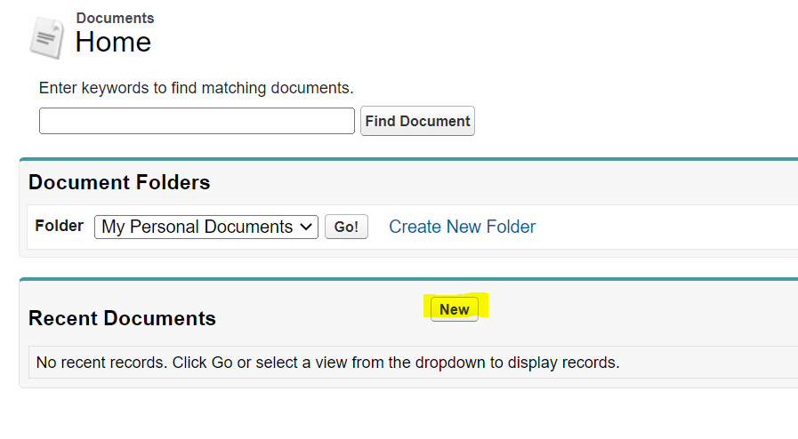

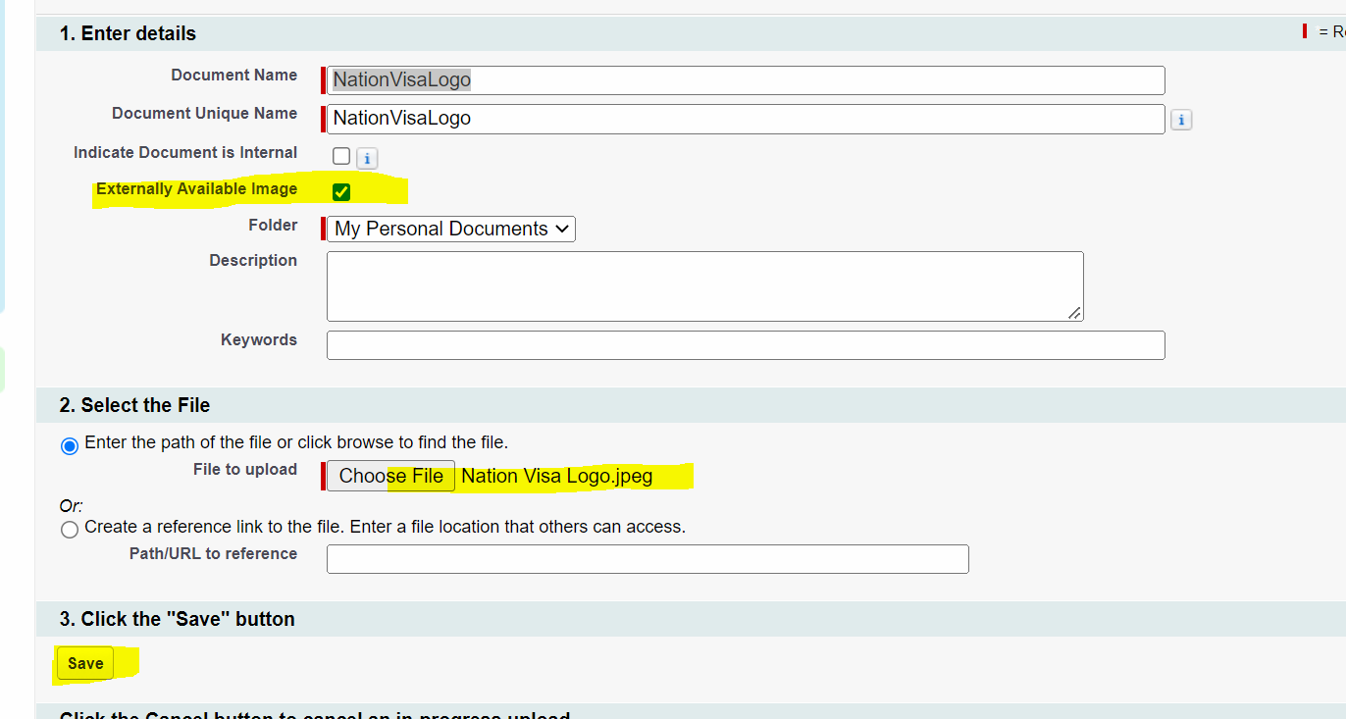

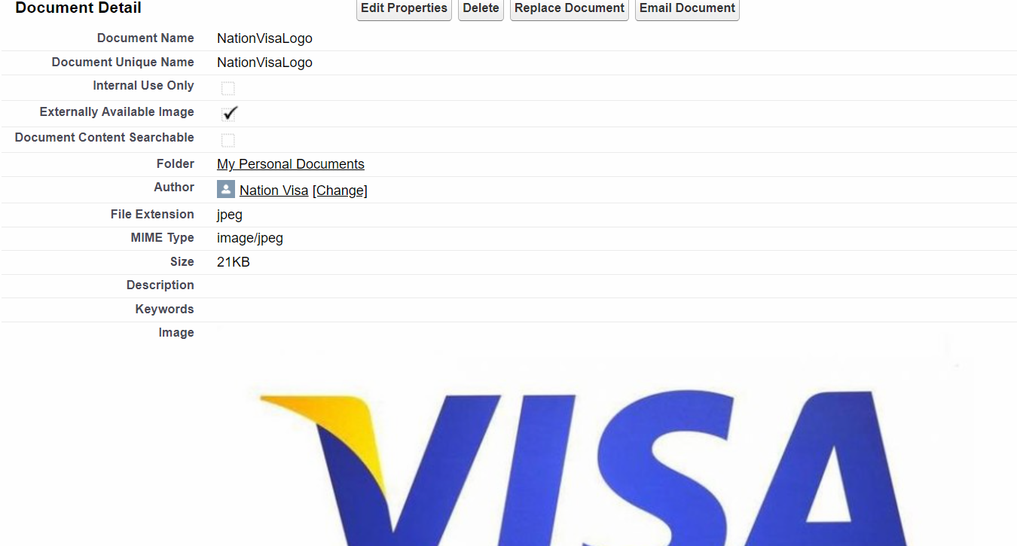

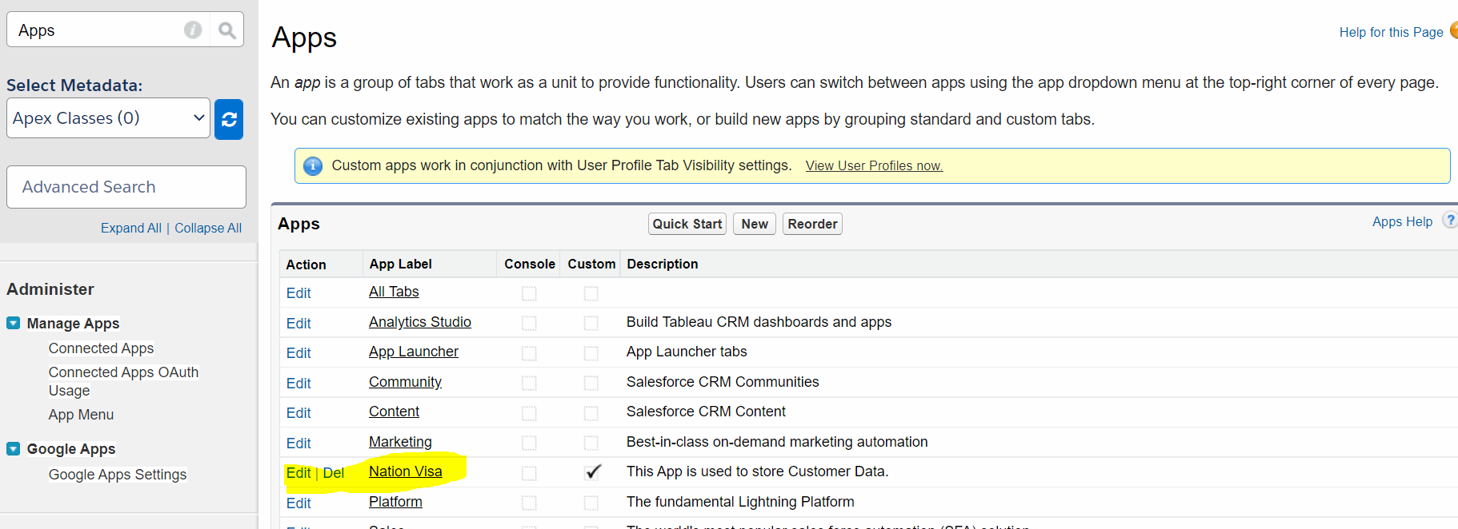

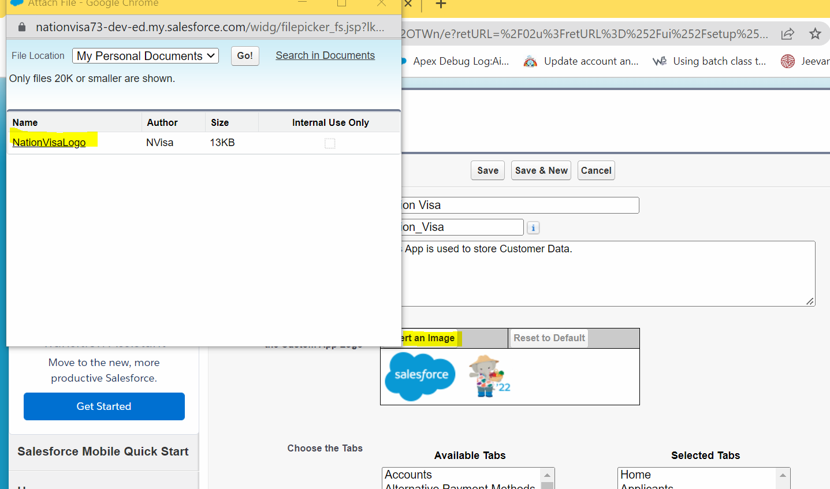

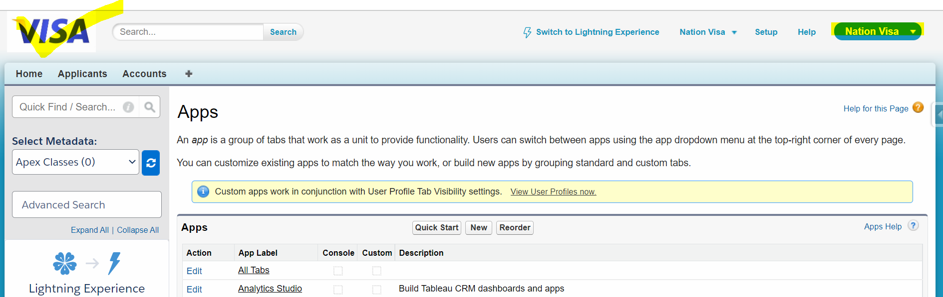

===================================================================================

Formula Field

Definition: Salesforce Formula Field is **a read-only field that derives its value from a formula expression you define**. The formula field is updated when any of the source fields change.

Age = ( Today – DOB ) / 365

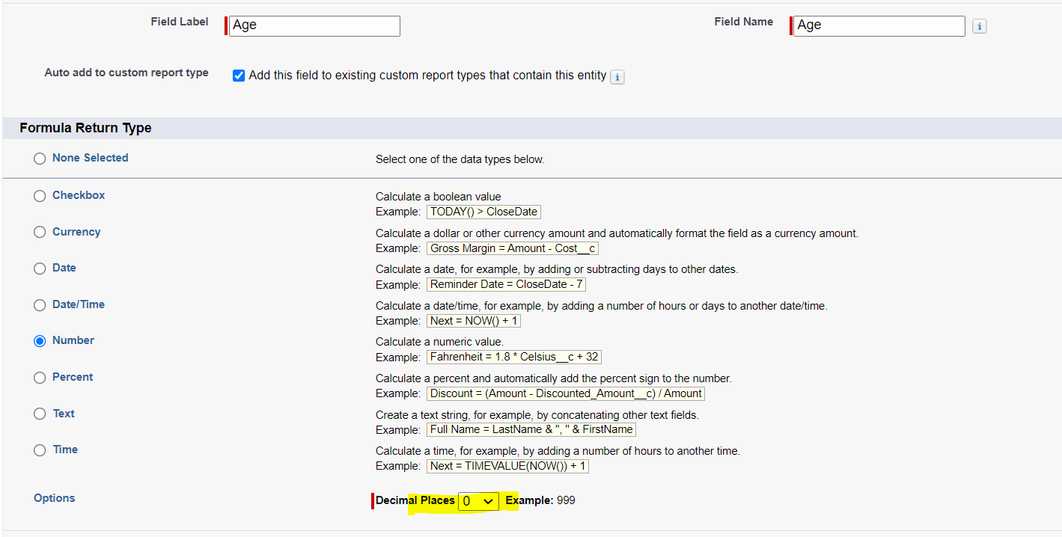

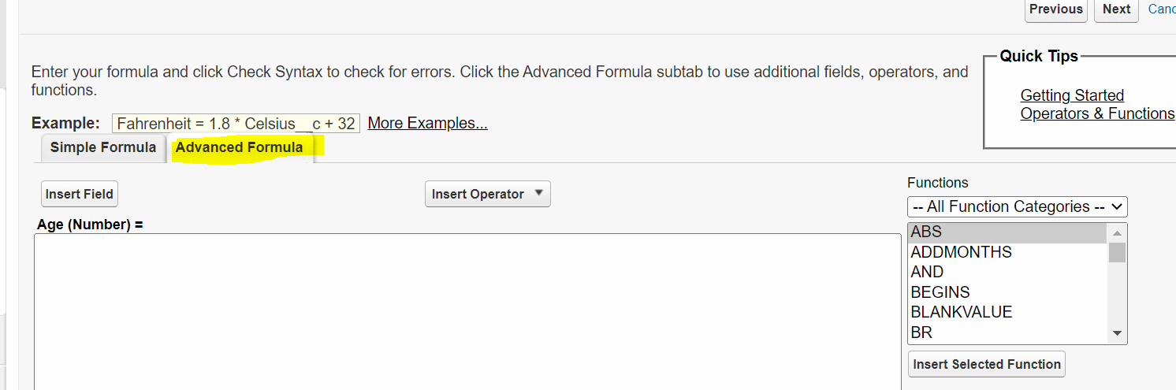

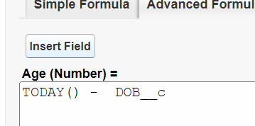

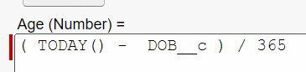

2] Create a Formula Field “Applicant Type” If Age >= 18, then Print “Major”, Else “Minor”.

Age = 20;

If(Age >= 18){

Major

}

Else{

Minor

}

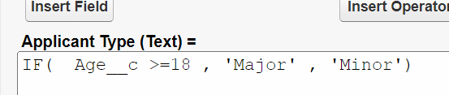

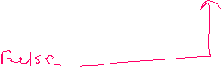

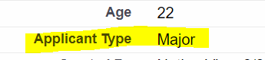

3] Create a formula field “Eligible for Voting”.

- If Age >=18, then Eligible for Voting should show Tick (Checkbox) = TRUE.

- Else, Untick (Checkbox) = FALSE

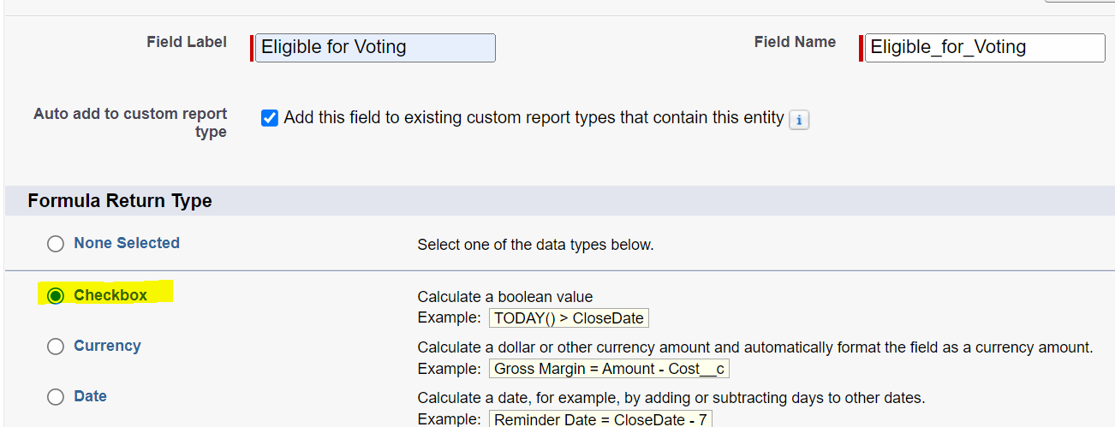

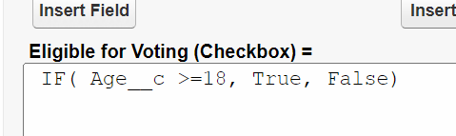



4] Create a Formula Field “My Lucky Number”.

- Lucky Number should be 33 for Major Applicant.

- Otherwise, Lucky Number must be 0.

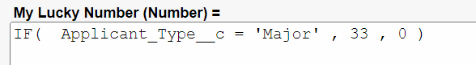

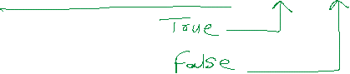

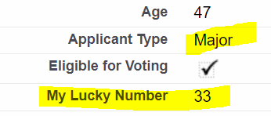

5] Create a Formula Field “Eligibility”. Show Eligible or Not Eligible Logo as per Age.

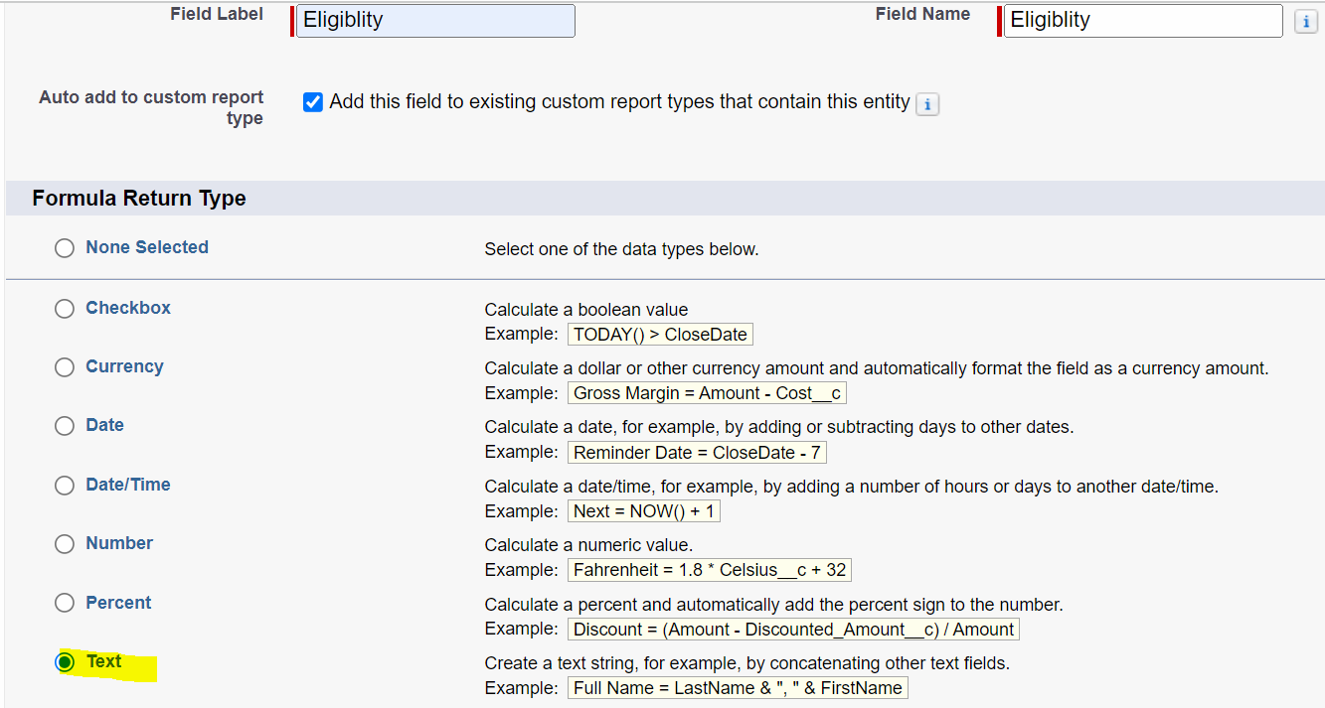

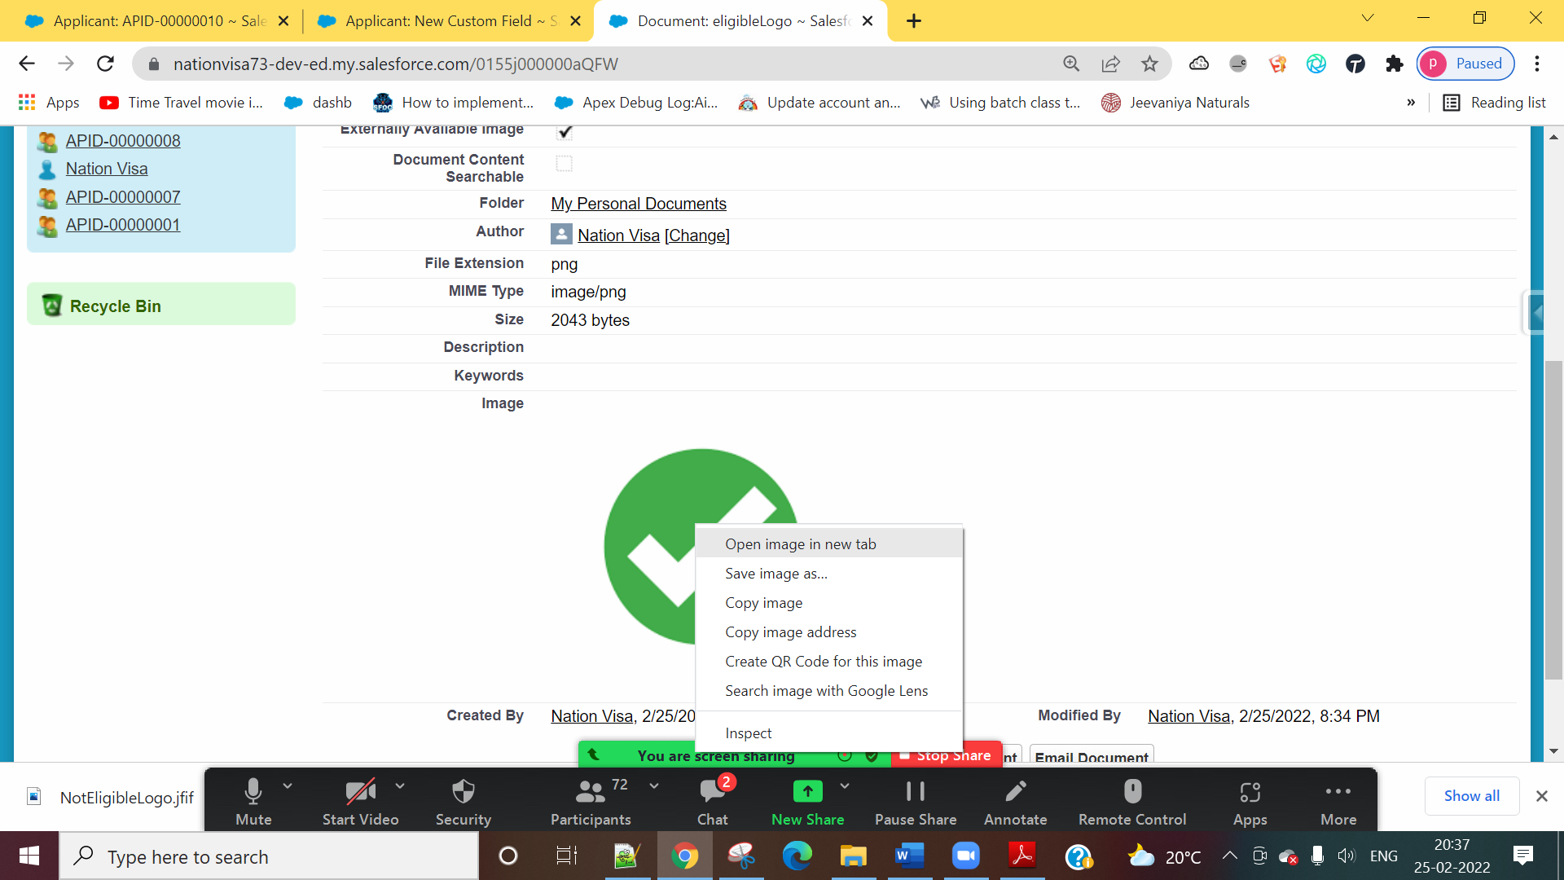

IF( Age__c >=18,

IMAGE('https://nationvisa73-dev-ed--c.documentforce.com/servlet/servlet.ImageServer?id=0155j000000aQFW&oid=00D5j000009kSca&lastMod=1645801441000', '' , 30, 30 )

,

IMAGE('https://nationvisa73-dev-ed--c.documentforce.com/servlet/servlet.ImageServer?id=0155j000000aQFb&oid=00D5j000009kSca&lastMod=1645801474000', '' ,30,30 )

)

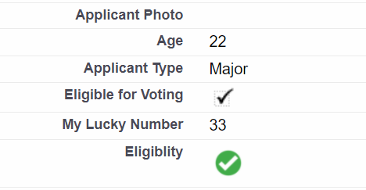

6] Create a Formula Field “Applicant Reputation”

- If Age >=18 and Eligible for Police Verification, Print ‘Bad’

- Otherwise 🡪 Print ‘Good’

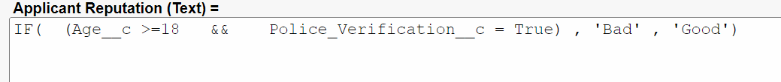

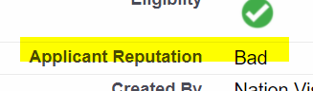

Salesforce Formula Functions:

https://help.salesforce.com/s/articleView?id=sf.customize_functions.htm&type=5

ASSIGNMENT:

Create a field Gender Logo. Show Male Logo OR Female Logo as per the Gender. Show in the List View.